PsiMX

Psion Series 5 control of FUJI MX-700 Camera

V0.2

Author: Phil Pugh (phil@comberbach.freeserve.co.uk)

Introduction

This software was written as a first try at OPL programming on a PSION 5. Although a few similar WINDOWS PC programs exist, I needed an easily portable set-up and my PSION 5 fitted the bill. There are no easily available official specifications for the FUJI MX-700 protocol as FUJI don’t/won’t publish them to private individuals. The software FUJI supplies with the MX-700 allows a form of remote control but no time-lapse facility and only runs on PC and MAC.

I gathered most of my knowledge of the protocol from sources on the WWW.

Thierry Bousch has a complete list of commands to which the FUJI camera responds. His Fujiplay s/w contains documentation.

http://topo.math.u-psud.fr/~bousch/fujiplay.html

TsuruZoh Tachibanaya who has some Windows based utilities for controlling a FUJI camera. I was in correspondence with TsuruZoh about how some of his s/w worked.
http://www.butaman.ne.jp:8000/~tsuruzoh/index-e.html

My thanks go out to these people who have provided useful insights into the workings of the FUJI protocol and MX-700 serial port. I have only tried out this s/w with my MX-700 although some of the commands may work with other FUJI digital cameras. The author would be pleased to hear of success/failure with other FUJI cameras. (See known limitations later).

Aims of the program.

I deliberately wanted a program that would provide basic camera control ranging from ‘Take a picture’ to timelapse. I have not implemented any of the picture download commands as I see little point in loading information from a 16Mb or 32Mb Smartmedia card into my 24Mb (8 +16) Psion series 5. It may do many things but displaying 1Mb+ 24bit colour pictures isn’t one of them (yet ☺).

Installation

Create a folder PsiMX, in the \SYSTEM\APPS folder
Copy the PsiMX.app and PsiMX.aif to C:\SYSTEM\APPS\PsiMX.
An icon (of an MX-700) should appear in the Extras menu as usual.

Description of Operation

Connection of Camera to PSION

The cables supplied with both the PSION and the MX-700 are intended to connect to a PC via a 9 pin sub-D connector. Both are female connectors. You will need to use a modem cable (i.e. one that swaps the transmit and receive pins over) that has male connectors at each end. These are generally available from good PC stores.

Running PsiMX

PsiMX is available from the Extras menu.

Turn on the camera and set it to PC mode before running the PsiMX application. When PsiMX starts you are prompted to do this before continuing.

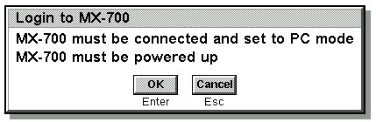

Selecting OK instigates the link connection. PsiMX will try 3 times to do this (a total of 15-20 seconds) and an error message will be displayed if it cannot connect. PsiMX terminates for most error conditions, as there doesn’t seem to be a way of overcoming many of the errors returned by the MX-700.

The Menu

After successfully establishing the link a simple menu is displayed.

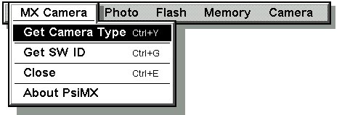
The menu is split into 5 main areas.

MX Camera (see above)

Get Camera type. This returns the MX-700’s identity string

Get SW Id. Returns the camera’s software version number and name.

(These are useful commands to check out the connection).

Close. Exits the application.

About PsiMX. Some information including version number and my e-mail address.

Photo
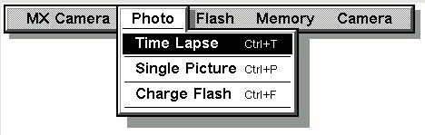

Time Lapse. Takes a sequence of pictures. The user is prompted for the delay between and number of pictures to take. A minimum of 10 seconds between each picture is enforced. During the last 2 seconds before a picture is taken the PSION will beep. An on-screen countdown is displayed. The flash is charged between each picture – even if it has been disabled.

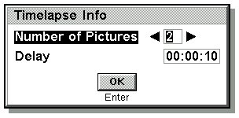

If the camera’s memory is filled before the requested number of pictures is taken then an error will be displayed and the program terminated. A running time lapse can be cancelled by pressing a key on the PSION.

Single Picture. Takes one picture – a digital remote release cable.

Charge Flash. Causes the camera’s flash unit to be charged up ready for taking a picture. It is usual to do this before taking a picture – even if the flash is switched off!
This command may take anything up to 20 seconds to complete.

Flash

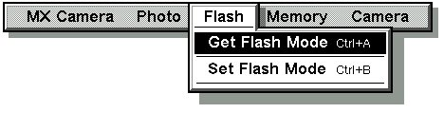
Get Flash Mode. This returns the current status of the flash. This can be one of; Off, Forced (on), Red-eye/strobe and Auto. Auto is the default setting.
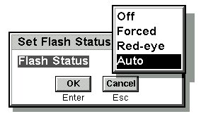
Set Flash Mode. This allows the flash to be set to any of the above modes. It will remain in this mode until reset or the camera is turned off.

Memory
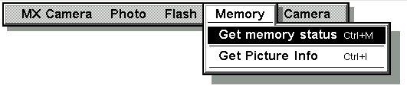
Get memory status. Returns the amount of free memory in the camera together with the number of pictures stored in the camera.

Get Picture Info. Returns the filename and size of an individual picture. The user is prompted for the picture number.

Camera.

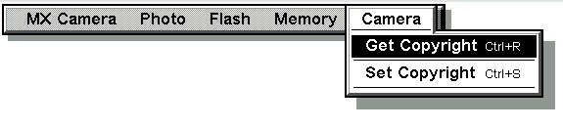
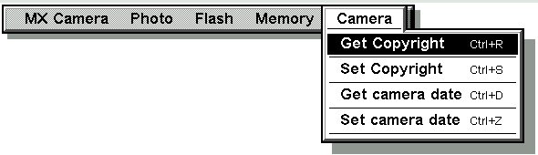
Get Copyright. Returns the 10-character string stored in the camera. This string is written to the copyright field in the EXIF header of each picture file taken subsequently.

Set Copyright. Allows the user to set the copyright information. The user is prompted for a 10-character string. This is padded with spaces if shorter than 10 characters.

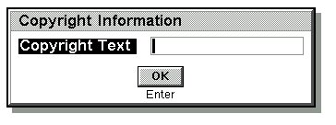
Get Camera Date. This command returns the date stored in the camera.

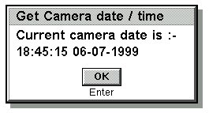

Set Camera Date. This command sets the camera date to that of the PSION. This is a useful feature as the date in the camera will reset when there is no battery present, or the battery has run down – which Lithium-Ion batteries do over time. The display above (Get Camera Date) is re-displayed to confirm the actual camera date.

Known Limitations.

PsiMX has simple error handling at present. All errors cause messages to be displayed on the PSION and will generally cause the program to exit. Upto 20 seconds may elapse before a message is displayed – this is due to timeout settings on the FUJI.

If you are experiencing many errors I suggest you close PsiMX, turn off the MX-700, turn on the MX-700 and re-start PsiMX. It is recommended that you have the camera (and PSION) under mains power if they are to be used over an extended period of time. You can use the Cntl-Shift-E form the system panel to close PsiMX. PsiMX does not store any information on the PSION.

I will probably improve the handling of errors, that is attempt to continue processing where possible, in a future release. I have found the program to be stable but I have not done exhaustive testing of the time lapse. You can set the interval to many hours, but I have only tested it over minutes worth of delay.

PsiMX may work with other FUJI digital cameras but some of the commands I have implemented may not work on some models. I have no direct experience of other models but I believe, for example, the MX-600 doesn’t allow the take picture command!
Protocol Description (for those who are interested).

The protocol is fairly basic and comprises a physical link layer overlaid with a simple binary protocol.

The physical link is Asynchronous serial line, 8 bit binary data, Even parity, 1 Start bit, 1 Stop bit with no flow control. The connection is a stereo micro-jack that allows Receive, Transmit and Ground. The initial connection speed is 9600 bps. This may be changed up to 57,600 bps after the initial connection, although I haven’t implemented this feature, as I don’t need the link speed. A higher speed would be desirable if I needed to download pictures.

The binary protocol is of the form below. All data is represented a HEX bytes.

10 02 cc cc ll ll dd dd dd .... 10 tt kk

where
cc = Command value
ll = length of data
dd = data
tt = terminator (03 = command complete, 17 = command has more data to send)
kk is checksum

The checksum is a simple XOR of all data from cc up to the end including the tt byte but excluding the 10.

Being a binary protocol the value 10 may be a valid data byte. If a 10 is to be sent (or received) then it is followed by another 10. In this case the second 10 is NOT included in the length count or checksum calculation – it’s ‘thrown away’.

The length is transmitted least significant byte first.

An example command would be to charge the flash...

10 02 34 00 02 00 0A 00 10 03 08

Where 34 00 is the command.
02 00 is the length of data (2 bytes).
The data is 0A 00.
The checksum = 08 (34 ^ 00 ^ 02 ^ 00 ^ 0A ^ 00 ^ 03). I am using ^ to represent XOR.

Each command / response must be acknowledged with an ACK (06) or NAK (15) if not understood. Each command will also cause a response from the camera, which has the same format as above. Some commands (e.g. Show memory status) cause data to be returned for processing, others simply return a command code and length of 00 00, i.e. nothing!

The camera will respond with a 04 (on it’s own) under certain fatal conditions. The most common of these is low battery.

To initialise the link a 05 character, on it’s own, must be sent. The correct response is the 06 (ACK) character. The link is then active.

