Guitar Suite 2
The Instruction Manual

Machines supported by Guitar Suite 2

Psion Siena & Psion 3a & Psion 3c

Introduction to Guitar Suite 2
Guitar Suite 2 is now the second distributed version of Guitar Suite (originally coded in 1998). The main aim of the software has remained the same: to help guitarists owning Psion machines with chord shapes. The first version contained just 56 chords, but after progressing in both guitar and OPL programming, it was realised that this number was too insufficient. Although the user interface has remained the same, the main underlying program has changed tremendously due to a more efficient approach being discovered.

The new version now contains 216 chords! Instead of just one chord shape (usually within the first few frets), the new version shows 3 variations of the same chord to illustrate how it can be found further up the fret board. This should make playing from tablature easier as it is common for artists to use chord shapes found further up the fret board rather than the often-simpler shapes formed within the confines of the first few frets.

- Please note that all commands typed into the program are shown throughout this document in the following format: H (this means simply press key H irrespective of case as Guitar Suite 2 is not case sensitive).

Chords covered in Guitar Suite 2

Chords include:

+5, 11, 13, 5, 6, 7, 9, dim, m, maj, sus2, sus4

for chords A – G. As some of the above chords have alternative names, these are included in a section of this manual entitled ‘Alternative chord names’ and also in the online help available in the program by pressing H.

Installation

Initially, use either PsiWin or RCom software to place the following files in their respective directories. If you have difficulty with this, please consult your Psion manual or the file transfer software’s help.
Place guitar2.app in the APP directory and gtr.pic in the OPD directory (create it if it doesn’t exist M:\OPD)
Place guitar.wrd in the WRD directory

Then:
- On the system screen press ‘Menu’
- Goto ‘Apps’ then ‘Install’
- Select Guitar2.app
- Installation complete

Keys

A, B, C, D, E, F, G = brings up the chord dialog box for selection
H = brings up the online help
X = exits the program

The keys that can be used for the software are also shown on the screen preceding the title screen.

Tutorial

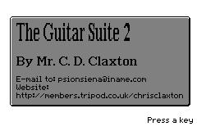
Once you have installed the software as described in the ‘Installation’ section, click on the Guitar icon and you will be presented with the following screen on the left.

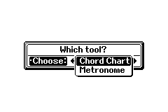
Press a key and you will be prompted to choose between either the ‘Chord Chart’ or ‘Metronome’ with a dialogue box.

Initially, we shall have a look at the chord chart facility, so select ‘Chord Chart’ and you will be presented with a small help screen displaying the keys:

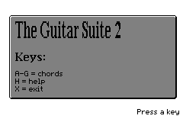

Press a key and the screen will be cleared, leaving a blank fret board as follows:
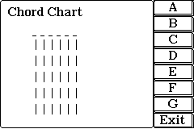

Now, let’s find out what the B7 chord looks like. Press B (not case-sensitive) and the following screen will appear:

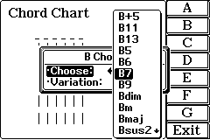
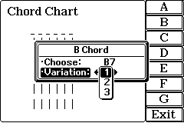
By pressing Tab on the ‘Choose:’ section, the entire list becomes visible. Select B7. The next step is to choose the variation and this simply chooses between three B7 shapes that are different positions on the fret board. The first variation (1) is usually the simpler of the shapes and within the first few frets, and as a rule, the third variation (3) is usually much further up the fret board. In this case, we shall choose the simplest shape, which is variation 1. So select variation 1. With the chord and variation chosen, the next screen that appears shows the fingering for the chord:

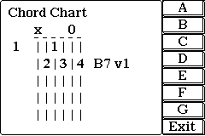

To make it easier to understand the diagram, please see the annotated diagram below:
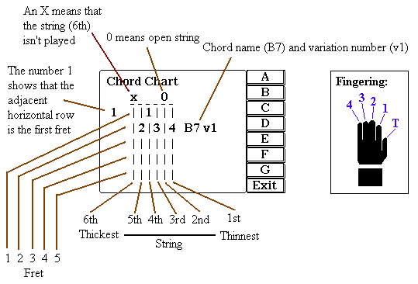

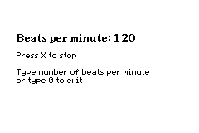
Now that you should have sufficient knowledge to use the ‘Chord Chart’, we shall move onto the Metronome. This just beeps at regular intervals set by the user. Initially, exit the program and click on the Guitar Suite 2 icon. When asked to select between the Chord Chart and the Metronome, select Metronome. You will then be presented with the screen on the left. Either enter 0 to exit or the number of beats per minute. Then, assuming that the Beeps setting on your Psion are on, you should hear beeps at the defined interval. If you hear nothing, then goto ‘Troubleshooting the Metronome’ section. In the screen on the left, I chose 120 bpm as shown at the top. Press X to stop the Metronome followed by 0 to exit or the next number for the beats per minute.
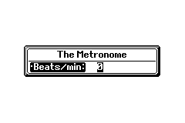

Alternative chord names

Chord | Alternative names
+5 | #5, 5+, aug, augm, augm5, augumented
11 | 11th
13 | 13th, dominant 13th
6 | 6th, M6, Maj6, Major 6th
7 | 7th, dominant seventh
9 | 7(add 9) or 9th
dim | 0, 0(7), dim7, diminished 7th
m | minor, min
sus2 | suspended 2
sus4 | (sus)F, 4, 4sus, add 4, add F, suspended 4, suspended 4th

Known problems with Guitar Suite 2

In the previous version, the Psion used to run out of memory if too many chords were examined. To remedy this, a lot of work was done to find the error, which happened to be due to the complex system of windows. Version 2 should not suffer from the problem at the cost of a slight flickering when the chord is cleared. It is hoped that later versions will have this problem sorted.

If you find any faults or bugs with the software than please let me know and I shall do my best to fix them in the next version.

Troubleshooting the Metronome

- If ‘Beeps’ are turned off on the system screen, you will not be able to hear the clicks. To turn the beeps on,
- Press ‘System’ on the touch sensitive buttons (System, Data, Word …)
- Press ‘Menu’
- Goto ‘Special’ and select ‘Control…’
- Click on ‘Sound’
- Select ‘Beeps’ and then either ‘Quiet’ or ‘Loud’ (Loud is recommended)

The Next Version

It is hoped that there will be another version of this successful piece of software. A feature that is being looked into is the ability of the user to be able to enter chords not currently present. However, if you have any ideas, then please let me know via e-mail.

Registration

When I fist programmed this software, I thought that I would put loads of 'nag' screens to get people to register and reduce the features considerably so that you had to register to get any use out of the software. HOWEVER, I realised that this would probably annoy users and did not let them evaluate it effectively and does not go with the shareware concept. For that reason, the downloaded software is complete, with NO restrictions - it is the fully working software.

If you use this software on a regular basis please register it so
that I may be able to continue producing software. To register, please send a cheque for £5 (pounds), made payable to Christopher Claxton to:

Christopher Claxton
7 Swansgate
Old Catton
Norwich
Norfolk
NR6 7HT

What you will get from registering:

- The piece of mind that you have helped the author to continue to
produce software.
- A newer version containing many more chords.
- Technical support via e-mail if required.

The Small Print (Legal Stuff)

1) Disclaimer: I Christopher Claxton do not accept any responsibility for damage to your Psion from running this program - although I cannot see how this could possibly occur given the source code. I also do not accept any responsibility for any loss of files or data - again extremely unlikely.

2) This program must not be reverse engineered.

3) This software is copyright and must not be altered in any way.

4) 'Guitar Suite' may be distributed freely provided that all the files exist intact and none have been removed, i.e. the following files MUST be in the zip file:

guitar2.opa
gtr.pic
manual.doc
readme.txt
guitar.wrd

5) The program remains solely the property of Mr. Christopher Claxton indefinitely.

6) The program may be publicly distributed on CD’s or disks or any other medium provided that consent has been obtained from the author. However, an e-mail is more than sufficient and usually don’t have any problems about its distribution.

9th August 1999

Christopher Claxton

© Christopher Claxton, 1999

To keep up-to-date with Guitar Suite, why not visit my web site? There are also tutorials in OPL (the Psion programming language) and lots of shareware software (currently over 90!). The URL is:

http://members.tripod.co.uk/chrisclaxton

If you wish to e-mail me, the address is:

psionsiena@iname.com

Please note that due to work commitments, I may not be able to send a reply immediately, but I endeavour to answer every e-mail within a reasonable amount of time.

