LINKING REVO TO LAPTOP BY IrDA
SET UP INFRARED LINK ON REVO:  From SYSTEM:  - press Ctrl + L to bring up Remote Link.  - select Infrared, then OK | (this action is only necessary if your Revo is set to CABLE for use on the cradle)
SET REVO TO LISTEN:  - touch IR logo on left of screen and select Infrared Receive | (start here if re-linking after time-out)
SET PC TO CONNECT:  - right click on LINK icon for Properties menu, then left click on Connect to establish PsiWin Link. | 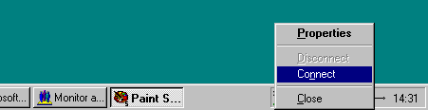
Observe link software starting.  Watch progress on icons at bottom of PC screen: | 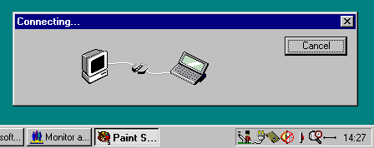
Stage 1 – no IR communication yet.
Stage 2 – PC & Revo communicating, but no link yet.
Stage 3 – PC gives up.
IMMEDIATELY press CANCEL on Revo screen. The PC should try again, and a few seconds later…
Stage 4 – Linked (animated wave shows data exchange)
Stage 5 – CopyAnywhere ready

IR MONITOR / OPTIONS | IR MONITOR / PREFERENCES
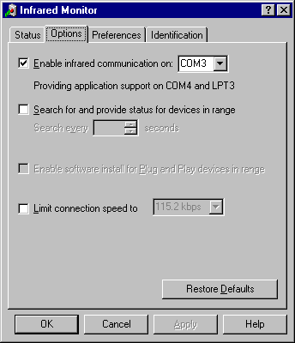 | 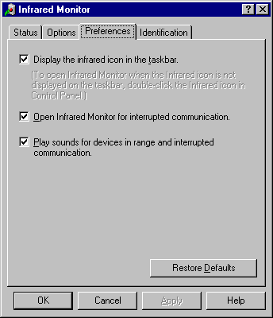
PSI-WIN SET UP: | CONTROL PANEL / SYSTEM / DEVICES
 | 